**Question 1**

**Create a function that takes a number as an argument and returns True or False depending on whether the number is symmetrical or not. A number is symmetrical when it is the same as its reverse.**

**Examples**

**is_symmetrical(7227) ➞ True**

**is_symmetrical(12567) ➞ False**

**is_symmetrical(44444444) ➞ True**

**is_symmetrical(9939) ➞ False**

**is_symmetrical(1112111) ➞ True**

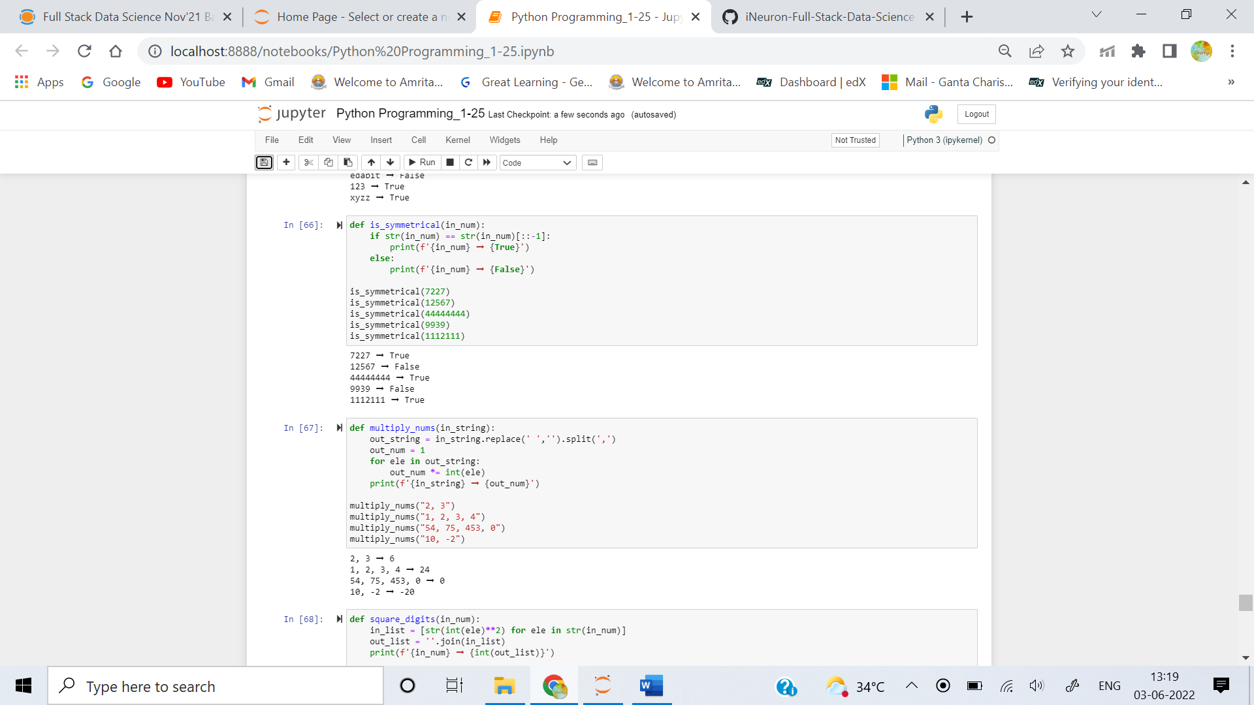

**Question 2**

**Given a string of numbers separated by a comma and space, return the product of the numbers.**

### Examples

**multiply_nums("2, 3") ➞ 6**

**multiply_nums("1, 2, 3, 4") ➞ 24**

**multiply_nums("54, 75, 453, 0") ➞ 0**

**multiply_nums("10, -2") ➞ -20**



**Question 3**

**Create a function that squares every digit of a number.**

### Examples

**square_digits(9119) ➞ 811181**

**square_digits(2483) ➞ 416649**

**square_digits(3212) ➞ 9414**

### Notes

**The function receives an integer and must return an integer.**

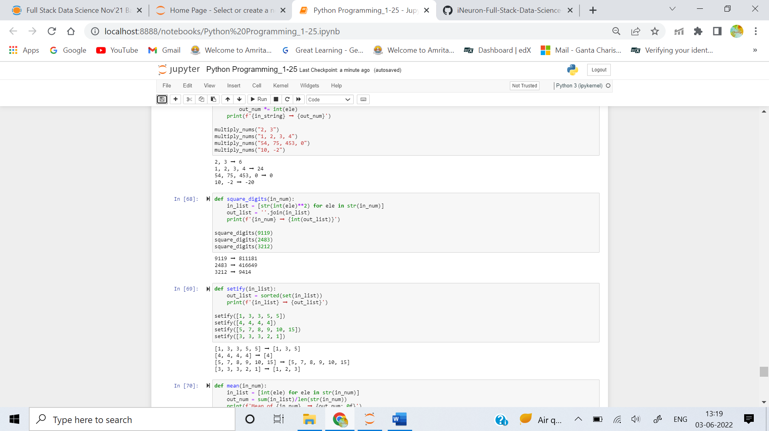

**Question 4**

**Create a function that sorts a list and removes all duplicate items from it.**

### Examples

**setify([1, 3, 3, 5, 5]) ➞ [1, 3, 5]**

**setify([4, 4, 4, 4]) ➞ [4]**

**setify([5, 7, 8, 9, 10, 15]) ➞ [5, 7, 8, 9, 10, 15]**

**setify([3, 3, 3, 2, 1]) ➞ [1, 2, 3]**



**Question 5**

**Create a function that returns the mean of all digits.**

### Examples

**mean(42) ➞ 3**

**mean(12345) ➞ 3**

**mean(666) ➞ 6**

### Notes

* **The mean of all digits is the sum of digits / how many digits there are (e.g. mean of digits in 512 is (5+1+2)/3(number of digits) = 8/3=2).**
* **The mean will always be an integer.**

